**ASSIGNMENT 2**

**AIM:** Design a Web Application Using HTML and CSS

**Code:**

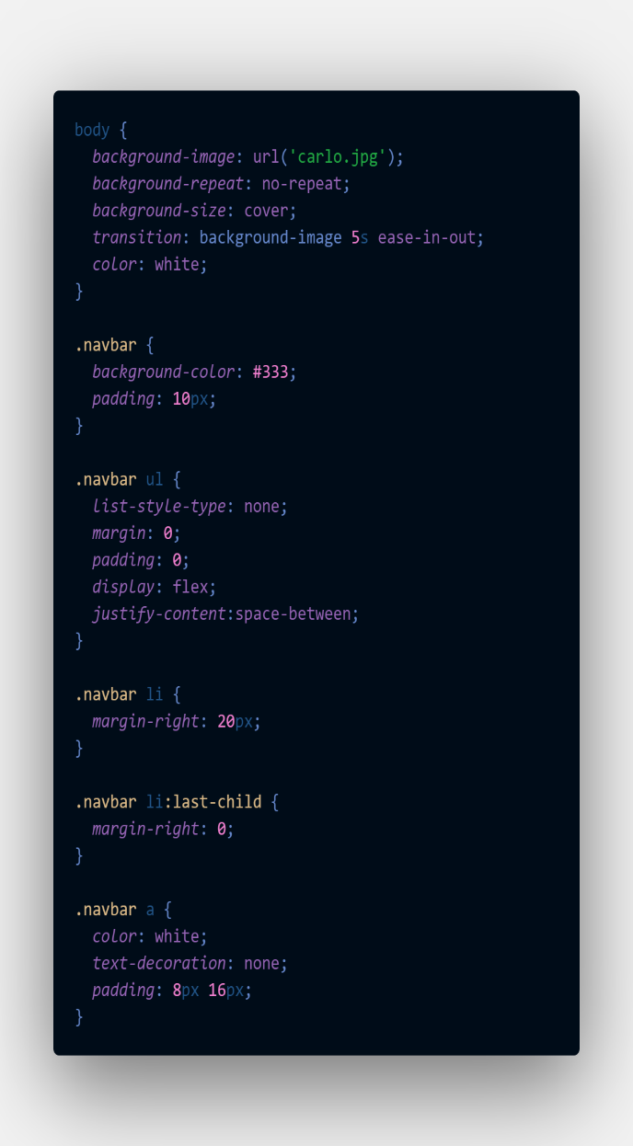

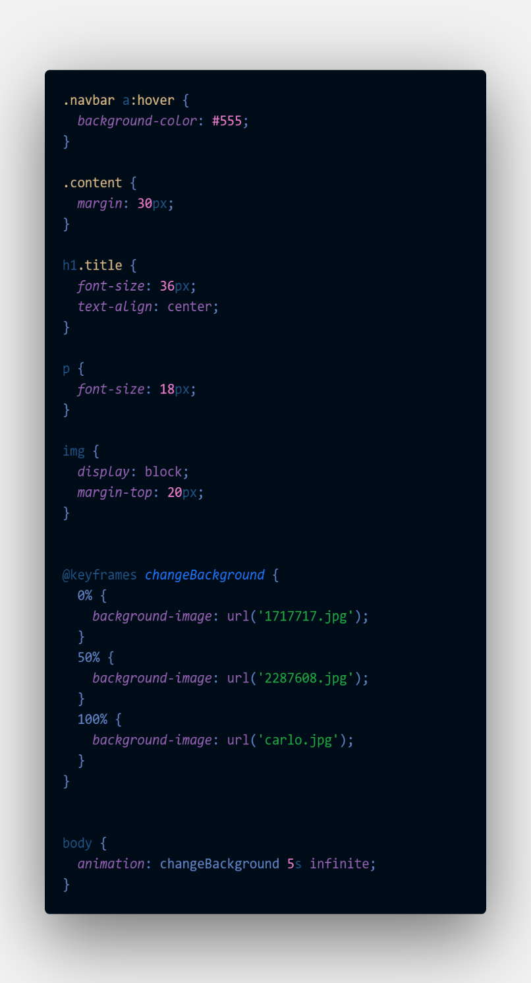

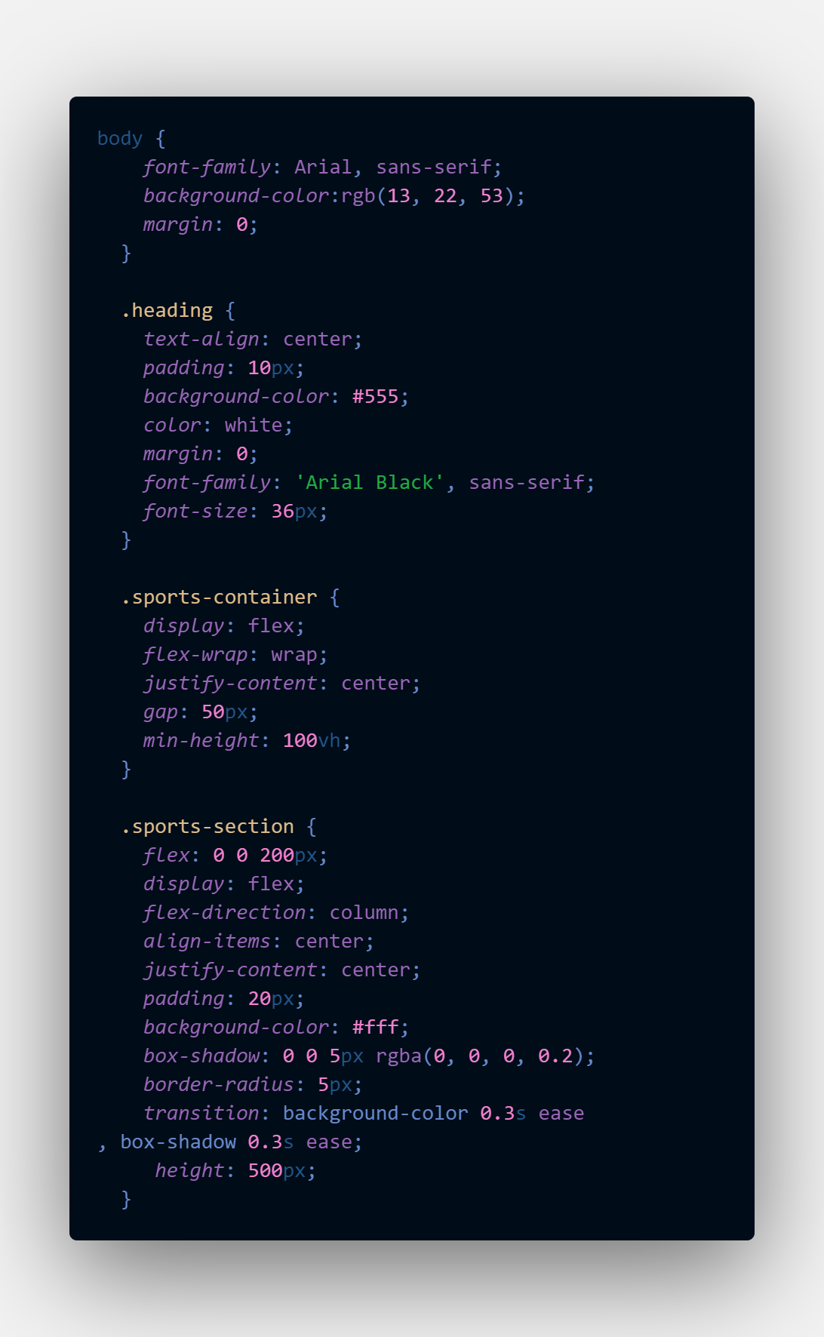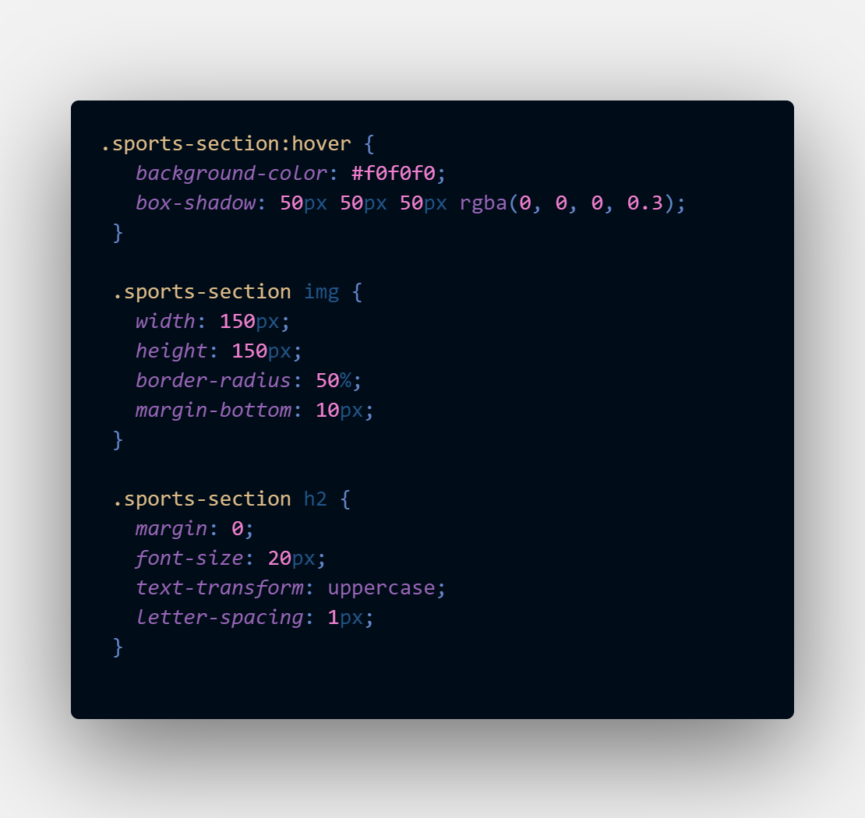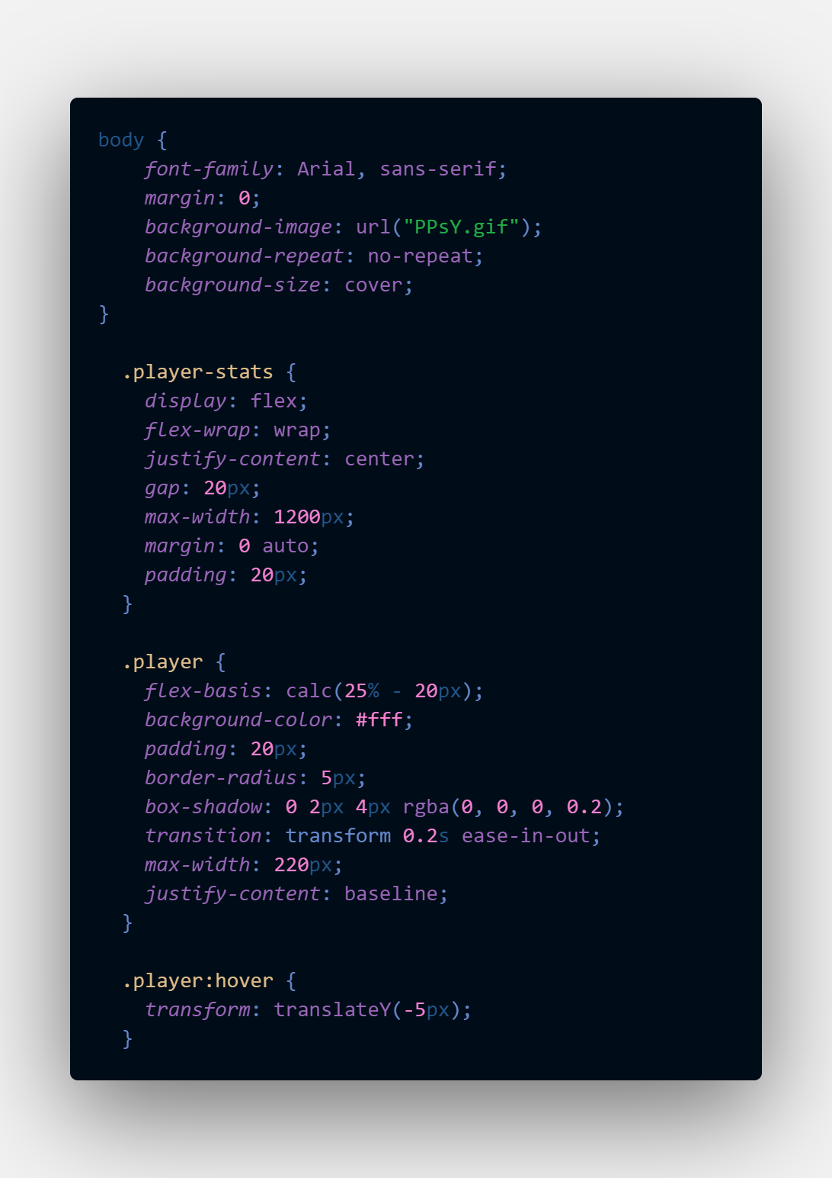

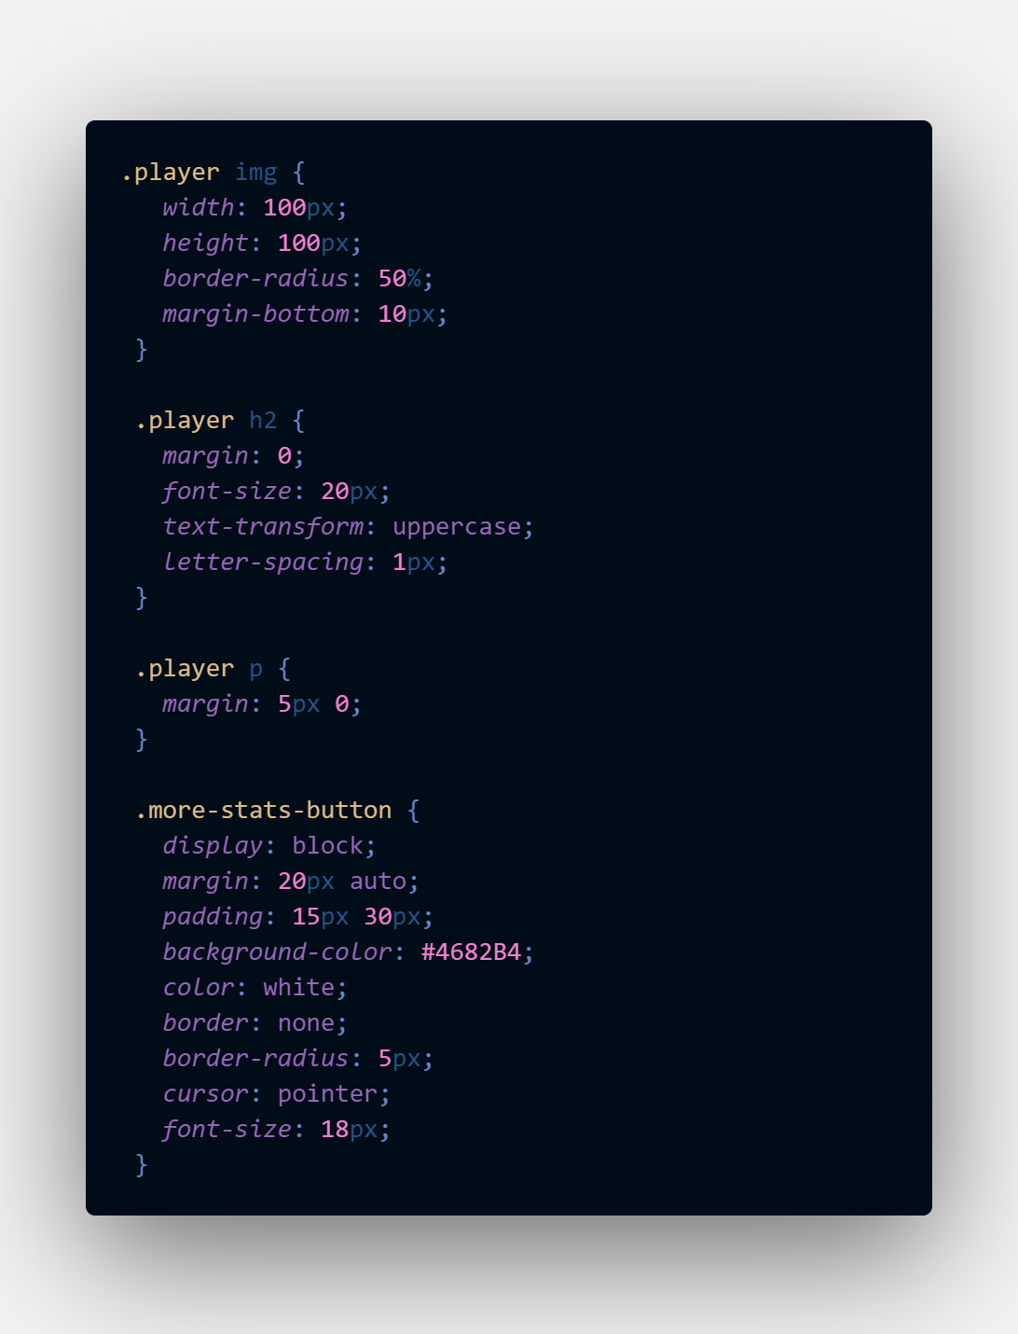

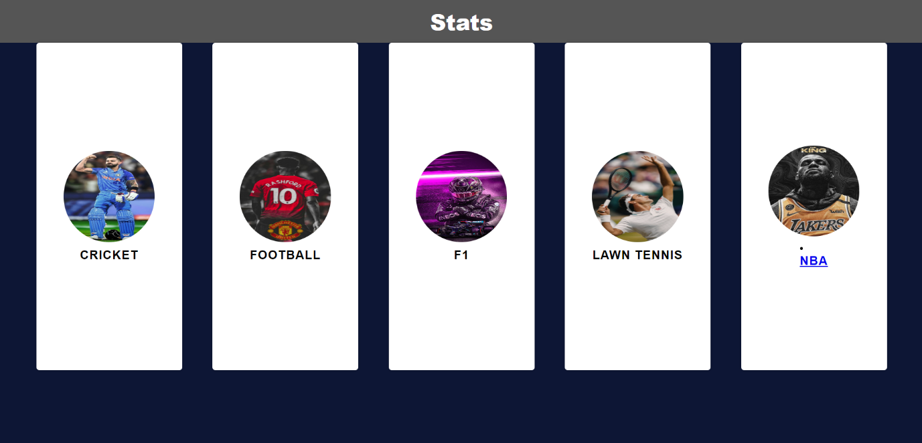

**Output**

**Conclusion:** A WebApplication was created with help of HTMl and CSS

* font-family: To set the font family for text elements.
* background-color: To set the background color for elements.
* margin: To set margins for elements.
* display: To specify the display property for elements (e.g., display: flex).
* flex-wrap: To control how flex items wrap inside a flex container.
* justify-content: To align flex items along the main axis of a flex container.
* gap: To set the gap between flex items inside a flex container.
* max-width: To set the maximum width for elements.
* padding: To set padding for elements.
* border-radius: To round the corners of elements.
* box-shadow: To apply a box shadow to elements.
* transition: To create smooth transitions for element changes.
* background-image: To set a background image for elements.
* background-repeat: To control how background images repeat.
* background-size: To control how background images are sized.
* background-position: To specify the position of background images.
* color: To set the text color for elements.
* text-align: To align text horizontally.
* text-decoration: To control text decoration (e.g., underline, none).
* font-size: To set the font size for text elements.
* text-transform: To control the capitalization of text.
* letter-spacing: To adjust the spacing between characters

